Hemel Hempstead Conservative Association
Leverstock Green and Woodhall Farm Branches
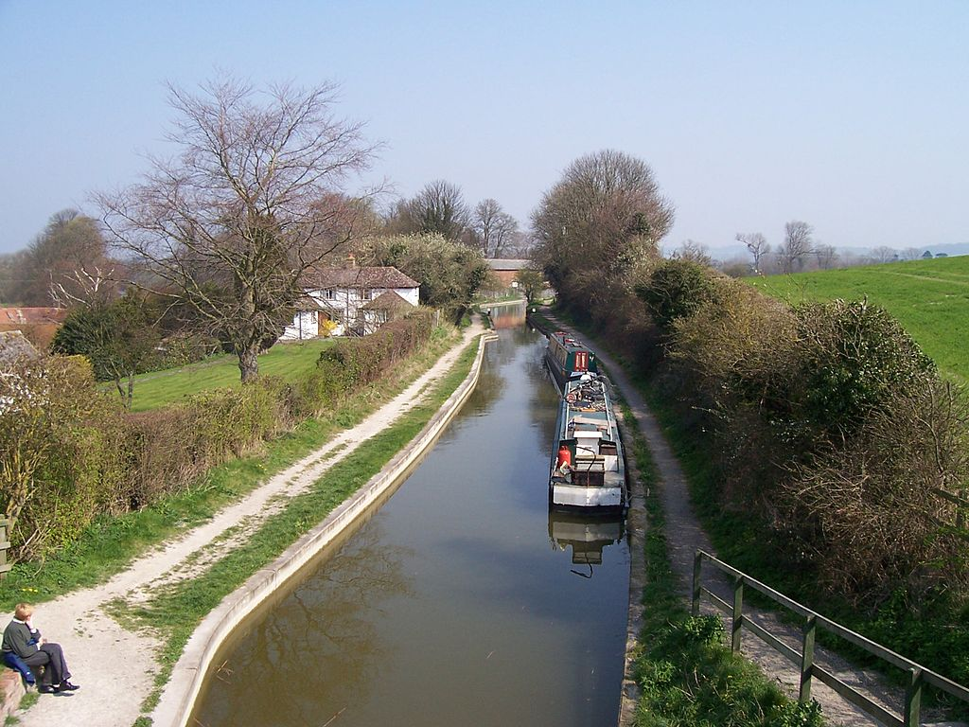
invite you to a
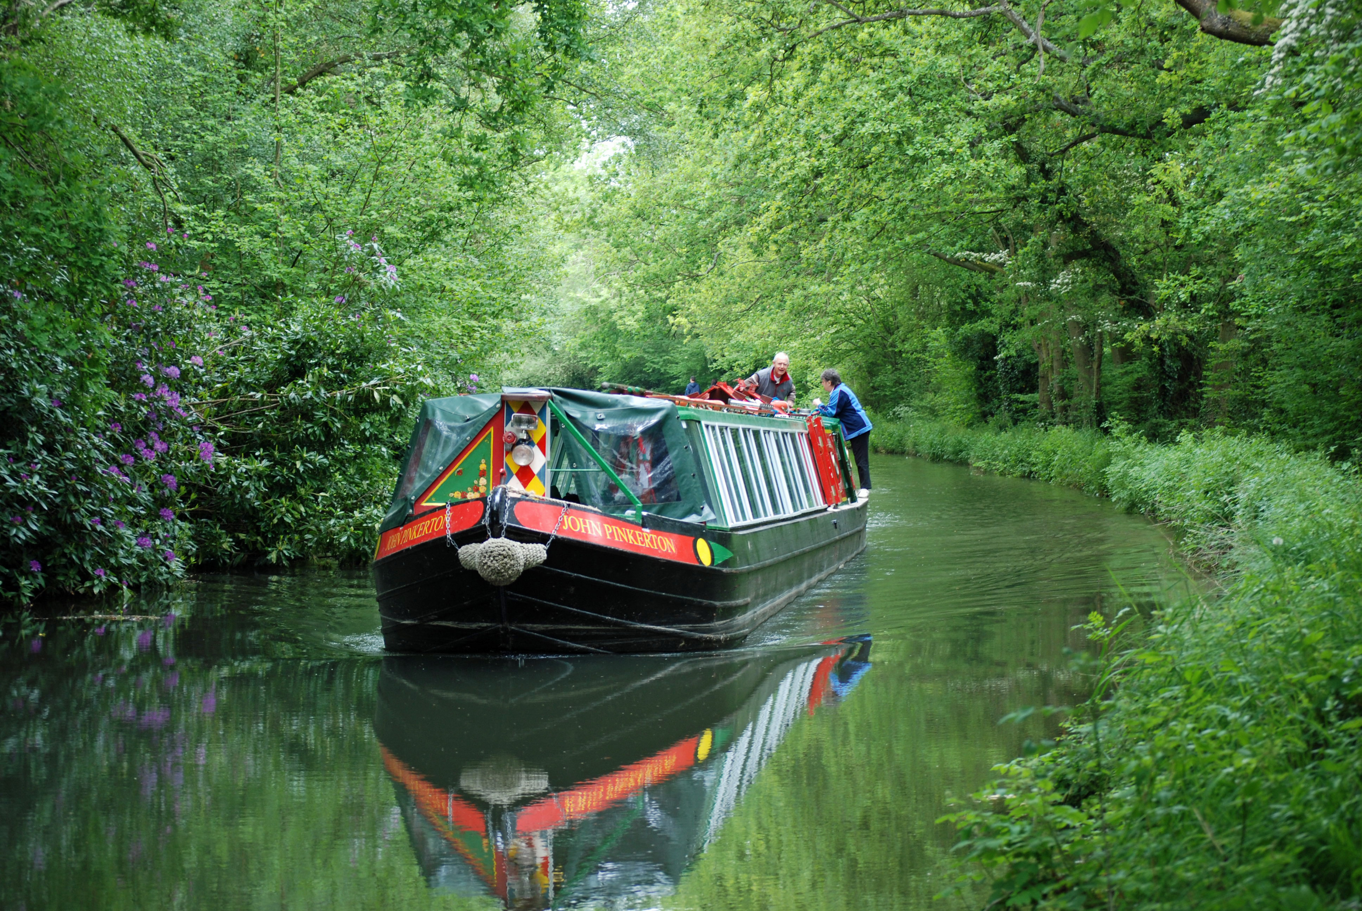

Canal Trip and Supper

on
Saturday 15th June 2019
5.00pm to 9.00pm

A fantastic way to relax. We will cruise along the canal at a leisurely 4 mph and take in the views you never knew existed on our doorstep. The boat will be crewed by friendly volunteers who will be only too pleased to “show you the ropes” and encourage you to help them through the locks.

Substantial buffet style salad with dessert and soft drinks.

Assemble: Nash Mills Recreation Centre. Red Lion Lane. Nash Mills. HP3 9TE.
Adequate Parking. Depart 5.00pm precisely

Tickets £20.00 Raffle
Limited space, first come first served Bring your own drinks

--------------------------------------------------------------------------------------------------------------------------
Leverstock Green and Woodhall Farm Branches
Canal Trip and Supper - Saturday 15th June 2019

Please reply to: Cllr Mrs Rosie Sutton, 67 Northend, Hemel Hempstead, HP3 8TL.
Tel: 01442 262378. Email: rosiesutton@btinternet.com

Please reserve me/us ...................... places for the above at £20.00 each.

I/We enclose my/our cheque for £ .................. made payable to “Hemel Hempstead Conservative Association Leverstock Green Branch” or “HHCA Leverstock Green Branch”

I am/We are unable to attend but enclose a donation of £ ..............

I/We will provide a Raffle Prize Yes/No

I do not have a car and would appreciate a lift to and from Nash Mills Yes/No

Name ...................................................................................................................................……………

Address ...............................................................................................................................……………

Postcode .............................................. Tel No: .......................................................…

